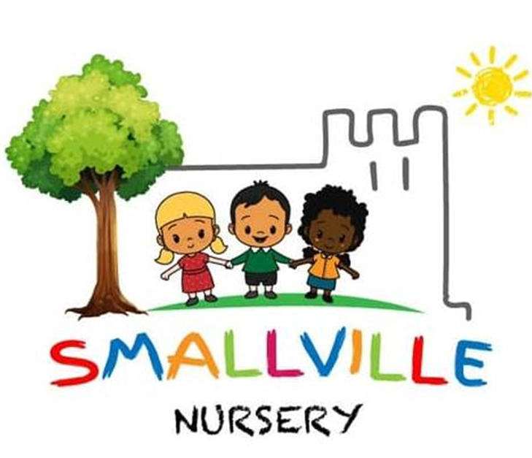

Smallville Nursery
Whistleblowing Policy
2024

This policy sets the principles in which any whistleblowing issues will be dealt with, subject to understanding that each case may need to be treated on its own individual merit. This policy applies to all staff working at Smallville Nursery.
Smallville Nursery is committed to the highest possible standards of openness, probity and accountability in the delivery of its services to its children, staff, parents and the general community. We have a wide range of rules, regulations, procedures, and codes of practice to deliver this commitment to prevent any malpractice, though unfortunately, this can still occour.
Employees are often the first to realise that there may be something seriously wrong within the nursery. People are often worried about raising such concerns because:

- They feel it isn’t their place or responsibility to raise the concern.
- They feel it may only be a suspicion.
- They feel it would be disloyal to raise a concern.
- They feel worried about raising the issue in the wrong way, or to the wrong person.

Please note that the Trade Union, professional organisation, or regulatory body can play a valuable role in assisting you to raise concerns under this policy.

Smallville nursery will not tolerate such malpractice, abuse or wrongdoing, and expects all employees and others what work with us to voice any concerns that they have about what is happening at work. This policy was written to ensure that people working within the organisation feel confident to raise concerns within the organisation, and outlines how to raise these externally if you feel this is not appropriate.
It is the responsibility of everybody working within the organisation to protect the welfare of the children, and are obligated to raise any concerns that they have of such.

If you are unsure whether to use this procedure, or require independent advice at any stage of the process, you can contact:
PUBLIC CONCERN AT WORK
SUITE 306
16 BALDWINS GARDENS
LONFON
EC1N 7RJ
0207 404 6609
Public concern at work is a registered charity which promotes accountability and good governance in organisations and responsibility amongst individuals. This has been at the forefront of recent developments in self-regulation and public interest whistleblowing.

Malpractice, abuse, and wrongdoing can include a variety of issues (some of which are listed in appendix b). This is not a comprehensive list but intends to illustrate the sort of issues which may be raised under this policy. This policy is primarily for concerns where the interests of others or of Smallville Nursery itself are at risk. Thus, if you are aggrieved as an employee about your personal position please see the existing grievance policy.

If you raise a genuine concern under this whistleblowing policy, staff will not be at risk of losing their job or suffering any form of retribution as a result. If staff are acting in good faith, it does not matter that they may be mistaken. However, Smallville nursery will view any false or malicious allegations as a serious matter and such allegations will result in using the disciplinary procedure.
Smallville Nursery will not tolerate any harassment or victimisation (including informal pressures) and will take appropriate action to protect employees if they are raising a concern in good faith.

Staff may feel that to keep their confidence when dealing with a whistleblowing concern, their identity should be protected. The managers will not directly identify any person raising concerns, however, at times, Smallville nursery may be unable to resolve the concern without revealing the identity of such person (e.g. evidence in court) but if this occurs, this will be discussed.

Any concerns that have been raised either orally or in writing, as well as those who wish to make a written statement should set out the background and history of the concern (giving relevant dates) and the reasons why there is cause for concern. The earlier that concerns are expressed, the easier it will be to act.

IF YOU ARE IN ANY DOUBT – RAISE IT.

Smallville Nursery will not expect you to prove that your concern is true, but it will need to be demonstrated that there are reasonable grounds to raise an issue.
It is acceptable for concerns to be discussed with colleagues, should this be more comforting, or if the same things have been experienced.
If you are an employee at Smallville Nursery with a concern about malpractice, abuse or wrongdoing, we hope that this can be raised with the nursery manager (Victoria East).

- Once the manager is aware of the concern, a member of the management team will investigate the matter to assess what action should initially be taken. This may involve an internal enquiry or a more formal investigation. We will tell you who is handling the matter, how you can contact him/her and whether your further assistance may be needed. If you request, we will write to you summarising your concern and setting out how we propose to handle it.

- It may be necessary to arrange a meeting with you and if you so wish you can be accompanied by a Trade Union representative or a work colleague.
- Where it is considered appropriate, the matters raised may be referred to external agencies to investigate, e.g. the Police, external auditor or through some other form of independent inquiry. We will of course, tell you if this is going to happen.
- Within 10 working days of a concern being raised by you, the person handling the matter will write to you:-

( a ) acknowledging that the concern has been received. ( b ) indicating how we propose to deal with the matter.
( c ) giving an estimate of how long it will take to provide a final response. ( d ) telling you whether any initial enquiries are being made.
( e ) supplying you with information on staff support mechanisms.

( f ) telling you whether further investigations will take place, and if not, why not.
Whilst the purpose of this policy is to enable us to investigate your concerns of malpractice, abuse or wrongdoing and take appropriate steps to deal with it, we will give you as much feedback as we properly can. Please note that we may not be able to tell you the precise action we take where this would infringe a duty of confidence owed by us to someone else.

- Smallville Nursery will take steps to minimise any difficulties which you may experience because of raising the concern. Thus, if you are required to give evidence in criminal or disciplinary proceedings Smallville Nursery will arrange for you to receive advice about the procedure.

